Winner | Awarded projects | Honorable mentions
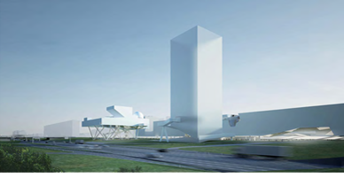
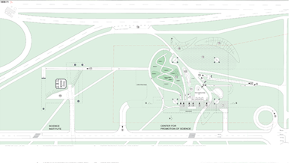
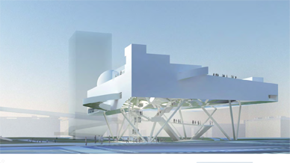
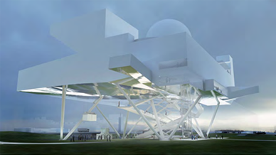
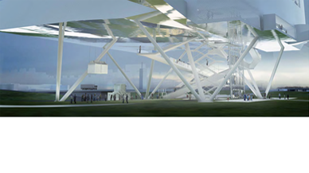
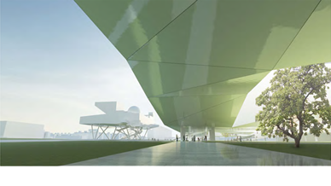
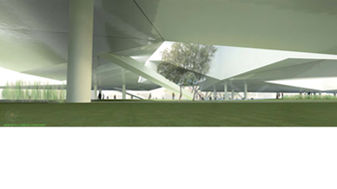
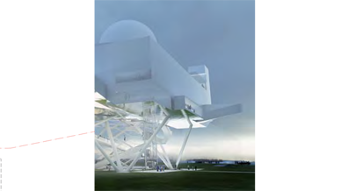
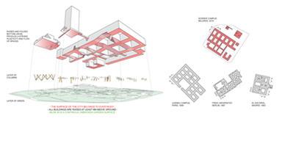
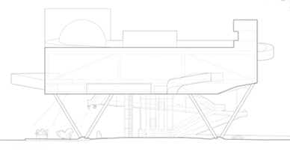
< 02/10 >
1. Prize:
Working code: 103
Identification code: 110106AA
Authors and co-authors:
Wolfgang Tschapeller
ZTGMBH Architekten
Wien, Oesterreich
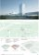



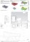
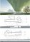
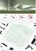
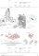


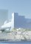
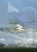
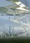

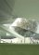
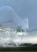
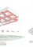

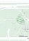

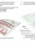
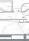


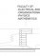

GENERAL URBAN CONCEPT FOR BLOCK 39
New Belgrade is a city of our times, a city which was invented and planned in the course of the 20th century with a decisive modernist perspective. Soleil (sun), Verdure (greenery), Espace (space) as well as functional segregation together with the rules of CIAM where main arguments of New Belgrade. Now, 60 years later, how do we read New Belgrade and how do we want to continue ist construction? We decided for a few very simple spatial tools, all of them being in close discourse with the principles of modernism. Firstly, we are opting for an elevated city detached from the ground. Only pillars and elements of circulation shall touch on the ground. We are proposing a floating city, very much in the manner of Corbusiers 5 points of architecture, buildings on pilotis giving the entire ground free. Secondly, the entire site is usable and accessible by everybody. Buildings do not block vision and movement. The terrain will be occupied with a multitude of different vegetations, exotic and local plants, waterlines, bike routes, jogging path. The functional segregation of the modernist movement is replaced by the
complexity of simultaneities. Below ground a slab of parking and serving functions. The ground level is covered by a variety of vegetations and allows for a city of pedestrians. 65% of the site are green and allmost all of the ground level allows for free vision.
A high density of programme is possible. As model of reference we propose the Jussieu Campus of Sorbonne in Paris. The Jussieu campus is composed of a grid of courtyards each measuring 33m x 48m and the entire block is elevated giving free a ground floor zone of approx. 5m hight. Thus all the spaces of the different courtyards are interconnected and a spatial flow between the courtyards is produced. The basic measurement of 33m x 48m of the Jussieu Campus is adopted for Blok 39 in Belgrade. The urban programme for Blok 39 forsees a ground zone of 6m height to be kept free. Space shall flow from the frame of one courtyard to the other. To highten the flow of spaces the bottom view is sligthly ondulating, consequently producing a strong plasticity of spaces and a variety of unexpected courtyard profiles.
GENERAL CONCEPT OF THE ARCHITECTURAL DESIGN OF THE CFPOS

The Center for Promotion of Sciences in Belgrade is detached from the ground. Following the urban concept it is a building floating high above the ground. It operates on 3 levels. Firstly, on the level of the City of Belgrade it will be an optimistic sign positioned on one of the main routes of the city . Secondly for Blok 39 it will be sign, canopy and portico. Thirdly, as a building being programmed to promote sciences it (dis)plays on visions of technology and construction. The architectural language of the center will strongly be one of technology and the display of structural principles. All exterior surfaces are of simple character. A special role is given to the underside of the center, it will have mirroring qualities, able to reflect all the movement on the ground as well as the visitor who by entering the center is penetrating the reflections of the earths surface.
DESCRIPTION OF OPERATIONAL AND SPATIAL RELATIONS OF CFPOS

The Center for Promotion of Sciences is composed as an architectural promenade. All visitors arrive in the CFPOSs outdoor area, below the protecting canopy of the CFPOS to which also the parking garage opens. The outdoor area is a very generous open space, being not only entry platform to the CFPOS but also entry pavillion to the University on Blok 39. Here you find resting areas, an outdoor bar, spots to meet, spots for discussion and the enclosed Science Garden, all these protected by green burms against the noise of the highway. Entering the main exhibition spaces of the CFPOS can be very fast. An array of express elevators allows acces to all levels and functions independently. However, more important is to understand the process of
entering and leaving the building as ceremony where one gradually uses the stairs or ramps from the open parking garage to the ground level, takes a first coffe at the outdoor bar, relaxes in the park under the protection of the canopy and gradually walks up the ramps, to the lobby, shop, cafe and further to exhibition spaces and planetarium, lecture hall, restaurant and science club, all of them grouped around the roof terrace. Entering and walking the building shall be an event in itself. All functions even including the generous roof terrace can be accessed independently. Exhibition spaces are placed on a large open platform around the workshop. All goods and exhibition pieces can be brought in fast and directly via a freight elevator from the parking garage.

STRUCTURAL DESIGN AND THE MATERIALS USED (see diagrams and description on presentation boards)

The CFPOS is an elevated frame construction with prestressed bubble decks. These voided biaxial flat slabs are enabling wide spans without losing the benefits of concrete slabs. Compared to a solid slab the reduced amount of concrete leads to less accelerated seismic mass and reduced energy & carbon emissions. The obviously simple designed and therefore cost-efficient steel superstructure easily supports the centre complex without leading to seismic vulnerability. Auger piles or diaphragm walls are providing the bearings of the steel superstructure. steel superstructure: 4 tripods: steel pipes d = 800 mm / d = 1000 mm, main columns and struts between the slabs: steel pipes d = 600 bubble decks: flat concrete slab with void formers, prestressed for optimal performance. h=750 mm. Deadload reduction of 30% compared to a solid concrete slab without losing fire- and sound-benefits. Stairways an additional structures like the dome theater and the conference hall can be easily suspended supported respectively. Deformations under quasi-permanent combination: The pre-stressed biaxial hollow deck shows an excellent displacement behaviour and is within the recommended range of the Eurocode. Deformations under seismic loads: Although the building is elevated, the supporting steel superstructure ensures good seismic behaviour. Additional bracings will enhance the behaviour of the dome theater and the conference hall. (see diagramms and description on presentation boards) Materials: The rough sculpural quality and the unorthodox massing are the main features of the building. These qualities allow for a modest and simple treatment of surfaces. Materials proposed are steel, concrete, glas, perforated steel membranes as shading devices, simple and monochrome cladding of the exterior skin, wooden decks for the terraces and roof gardens, light wall construction for the exterior walls. The undersight of the CFPOS will be covered by a low key mirroring membrane. Exhibtion spaces are of industrial quality and – except the rough sculptural quality in terms of volume and light – emphasis is on the exhibition settings.
Emergency exits and safety routes: Emergency exits and safety routes are calculated and designed according to the euro code. Assumed is a peak frequency of 2.000 visitors per day and an approximate capacity of 750 persons at any given moment.


http://www.blok39.com/index.php?option=com_content&view=article&id=58&Itemid=57
Cancel

